TAXI COMPANY MANAGEMENT SYSTEM : ANALYSIS AND DESIGN
1.SYSTEM REQUIREMENTS
The Taxi Company Management System operates as a centralized integrated information system in a single taxi company in which all vehicles are company owned.
The taxi company management system is the sole system of record for all operational data pertaining to booking driver activities vehicle status financial transactions and maintenance events.
System stakeholders
Stakeholders | Role
Admin | System owner and system operator  They have full oversight of fleet, staff and all kinds of reporting.
Taxi driver | Offer the trip service.  They are matched to the client by the system.
Client | End - user / customer.  They make bookings and payments for rides.
Payment  Gateway | External financial processor  It handles transaction request in a fat and secure manner.
Mechanic | Handles vehicle maintenance.  Works in the company garage to maintain and repair company vehicle.

Assumptions made in the system development
The following are assumption and dependences made in the system development:
- All vehicles in the fleet are owned by the company and therefore subject to centralized maintenance scheduling in the taxi company management system.
- Drivers are company employees and do not operate independently outside the taxi company management system.
- A reliable network connection is assumed for all system access points including driver mobile interfaces and the administrative console.
- The company has a secure agreement with a third – party payment gateway capable of processing card and mobile payment.
- Client interact with the system via a mobile or web interface.
Product functions
- Booking management receipt validation of trip availability checking of drivers and confirmation of client ride requests.
- Trip dispatch and tracking automated matching of clients to available drivers real-time GPS based on journey tracking
- Payment Processing: Fare computation based on distance, time, fuel, price and demand, multiple payment methods and receipt generation.
- Driver Management: Driver on boarding and credentials verifications shift scheduling and trip assignment and payroll computation.
- Fleet and Maintenance management: Vehicle registration condition based and calendar driven maintenance scheduling and fleet availability update.
- Reporting and Analytics: Aggregation of operation data across all data stores, computation of key performance indicators and generation of management reports.
Taxi company management system
Functional requirements
Functional requirements define the specific behaviors capabilities and interactions that the taxi company management system must support.
Booking management requirements
- They shall authenticate the client’s identity prior to processing any booking request using registered credentials and where applicable allow multiple factor authentication.
- The system shall validate all field of booking request including origin ( pick up location ) destination ( drop- off location ) requested date / time and passenger count are in accordance of business rules defined in the system.
- The system shall find real- time the nearest available driver in the vicinity of the pick- up location and return best match result ranked by proximity and driver rating .
- The system shall generate a unique identifier upon confirmation of a valid available booking.
- The system shall simultaneously update the status of the assigned driver upon booking confirmation, preventing assignment to other concurrent booking.
- The system shall persist the compete booking record inclusive of ( booking ID client references driver, reference , vehicle reference , pick - up location drop – off location and booking reference).
- The system shall dispatch a booking confirmation notification to the client including the assigned drivers name vehicle license number estimated duration of the journey within 30 seconds of confirmation.
- The system shall permit the client to cancel a confirmed booking without penalty if cancellation occurs no less than twenty minutes prior to the scheduled pick- up time.
KEY DATA STORES: Booking Database and Client Database.

Trip dispatch and requirements
- The system shall automatically identify the most suitable available driver for each confirmed booking based on (geographical proximity, driver performance rating and current duty status).
- Upon driver assignment the system shall update the booking status to completed free the driver’s status to available and transmit the trip log including start and end times total distance to the booking and driver database.
- Upon trip completion the system shall update the booking status to competed free the drivers status to available and transmit the trip log including start and end times total distance to the booking and driver database.
- The system shall transmit the competed trip record to the payment processing module ( to prompt fare calculation )
- The system shall provide the administration with a real – time view display of current location and status of all active drivers in their dashboard.

KEY DAY STORE: Booking Database and Driver Database.
Payment processing requirements
- The system shall calculate the total fare for each completed trip based on time distance and fuel price
- The system shall support only mobile money payment methods either through bank accounts or M-PESA.
- The system shall transmit payment request to the external payment gateway using encrypted format and process the gateway’s authorization or decline response with in ten seconds.
- The system shall rating a declined payment transaction up to two times before presenting a payment failure notification to the client
- The system shall generate a receipt for each successfully completed payment including booking id pick point and drop off point duration fare (applied tax) payment method and transaction ID.
- The system shall deliver the generated receipt to the client via email or ems within sixty seconds of payment confirmation.
- The system shall persist a complete payment record to the payments database including all fields in the receipt.
KEY DATA STORE: Payment Data Base
Driver management database
- The system shall collect and store complete driver profile upon registration including full legal name, national identification number, contact details. Bank account details, driver’s license number and license category
- The system shall issue unique system credential (user name and initial password, subject to mandatory change on first login) to each newly activated driver.
- The system shall enable administration to construct weekly shift schedules, assigning each driver to specific date start time end time and vehicle combinations
- The system shall notify drivers of their forthcoming shift assignments no less than 24 hours in advice via their registered notification channel.
- The system shall compute driver earnings at the conclusion of each payroll cycle based on the number of completed trips applicable per trip commission rate and any bonuses or deductions recorded by the administration.
- The system shall record all payroll disbursements as payment events in the payment database.
- The system shall generate a detailed pays lips for each driver at the conclusion of each pay roll cycle itemizing gross earnings individual dedication net pay and the period covered.
KEY DATA STORE: Driver Data Base
Fleet and maintenance management requirements
- The system shall support the registration of each vehicle in the fleet with these mandatory attributes (Registration plate, make model year of manufactures, engine capacity. seating capacity fuel type and insurance expiry date).
- The system shall require documented evidence of road worthiness to be recorded by mechanic prior to activating a vehicle for dispatch eligibility.
- The system shall generate and maintain a scheduled maintenance calendar for each vehicle incorporating calendar based schedule (every 90 days).
- The system shall create a formal work order for each scheduled or unscheduled maintenance event allocating the work to a specified mechanic and detailing required service tasks.
- The system shall automatically set the availability status of a vehicle to unavailable when it is scheduled for or undergoing maintenance, removing it from the dispatch pool.
- The system shall notify the responsible mechanic of a newly assigned work order at least 48 hrs. Prior to the scheduling date where scheduling permits.
- Upon mechanic completion and sign off of a work order the system will evaluate the vehicle reported condition and if satisfactory restore its availability status to “Available”.
- The system shall alert the administration when a vehicles insurance approaches expiry with in a warning period of 30 days.
- The system shall record a complete maintenance log entry for every maintenance event including: work order, number, vehicle, mechanic, date, tasks performance, parts used, labor hours, and cost.
KEY DATA STORE: Fleet Data Base and Maintenance Database.
Reporting and analytics requirements
- The system shall aggregated transactional data from all operational domains (Booking, clients, drivers, payment, fleet and maintenance) into a unified reporting data set.
- The system shall compute and present key performance indicators eg revenue per period revenue per trip, fleet utilization, maintenance costs.
- The system shall provide a real – time operational dashboard presenting number of active trips and available drivers.
- The system shall maintain an audit history of all administrative events for compliance regulations purpose.
- The system shall enable administrations to generate reports filtered by arbitrary combinations of driver’s vehicle payment method date.
Non – functional requirements
These are requirements that define the quality attributes, constraints and operational characteristics that the taxi company management system has in additional to the functional requirements.
Performance efficiency
- Booking confirmation and payment shall be completed and returned to the client with in five seconds under normal load condition.
- All reporting queries shall return results within five seconds for any date range not exceeding 12 months.
- GPS positional updates receive from driver devices shall be processed and reflected on the administrative dash board with in five seconds of receipt.
- The system shall sustain concurrent processing of at least 50 simultaneous booking transaction without degradation of response time.
Throughout this is the actual rate of successful data delivery over a communication channel.
Performance efficiency this is the degree to which a system performs its functions with in stated time and resource parameters under defined conditions.
Reliability
This is the degree to which the systems perform specified function under defined condition for a specifies period of time .availability: the taxi company management's system avail ability of 99.5℅ measured on the monthly basis excluding schedule maintenance windows (this shall be the server uptime)
In the event of a payment gateway communication failures the system shall queue the transaction and automatic retry processing up to three times within a 30 mins window before warning the administration.
Following an unplanned systems failure the taxi company management system shall restore full operational capability with in a mean to repair time window of no less than three hours.
All transactional data including bookings payment maintenance records and audit logs shall be backed up.
Security
This is the degree to which a systems protects information and data against unauthorized access use disclosure disruption modification or destruction.
All data transmitted between any client interface and the system server shall be encrypted.
All sensitive data field in the system database including national identification numbers banking details and payment card tokens shall be encrypted.
The system shall enforce role_ based access control (RBAC) with a minimum of four distinct roles. Administration, driver mechanic and client no user shall be granted access to function or data beyond those defined for their assigned roles.
The system shall lock any user account after five failed authentication attempts requiring administration intervention or a verified password reset work flow to restore access.
Client’s personal data shall be collected stored and processed in accordance with applicable data protection legislation. The system shall provide a mechanism for clients to request deletion of their personal data.
User ability
This is the degree to which a product can be used by specified users to achieve specified goals with effectiveness, efficiency and satisfaction.
Learnability 1: A new administration user with prior general computer literacy shall be able complete the five most common administrative tasks without external assistance.
Operability 2: All primary functions accessible to driver and mechanics shall be operable via a mobile optimized interface without requiring interaction targets than 9mm *9mm.
Error prevention 3: The system shall provide real-time in line validation and contextual guidance for all user -editable form field prior to submission preventing avoidable submission failures.
Maintainability
This is the degree of effectiveness and efficiency with which a product can be modified to improve it correct it or adapt to changes.
Modularity 2: The system architecture shall be designed as modules such that modifications to any single functional domain (for example payment processing ) do not necessitate changes to un related domains.
Testability 2: The system codebase shall achieve a minimum unit test of 80% testing frameworks coverage reporting tool.

Scalability
This is the degree to which a system can handle increased loads data and transaction without performance degradation.
Capacity 1: The system shall be designed to accommodate a minimum 200%/ increase in concurrent user load and stored volume through horizontal scaling mechanisms without the need of architectural redesign.
Horizontal scaling: This refers to the process of increasing the capacity or performance of a systems by adding more machines or servers to distribute the workload across a longer number of individual units.

2.DFD
Data flow diagram (level 0)
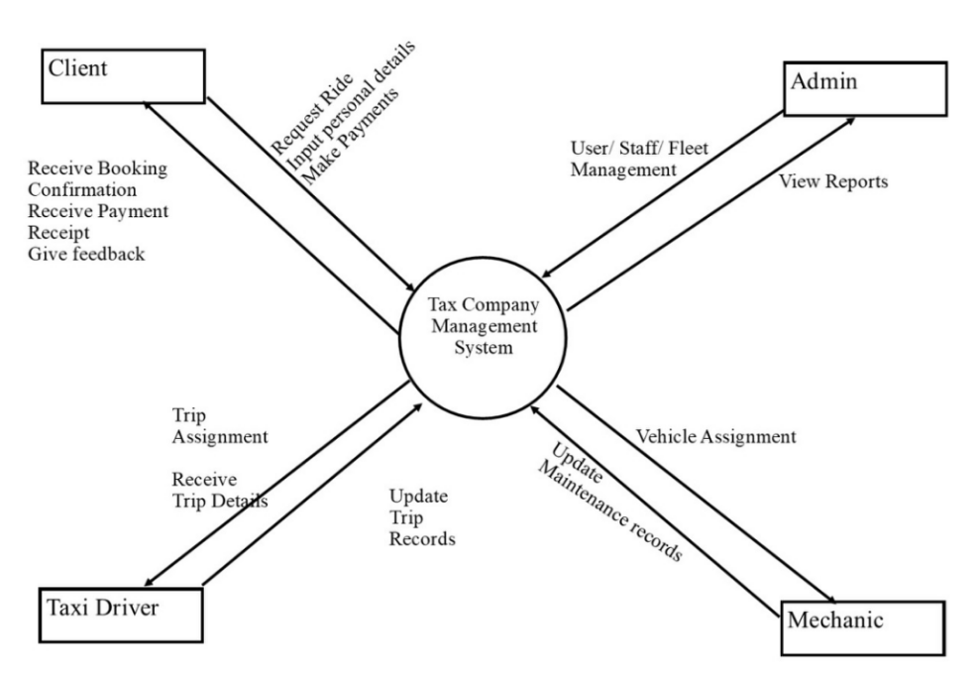

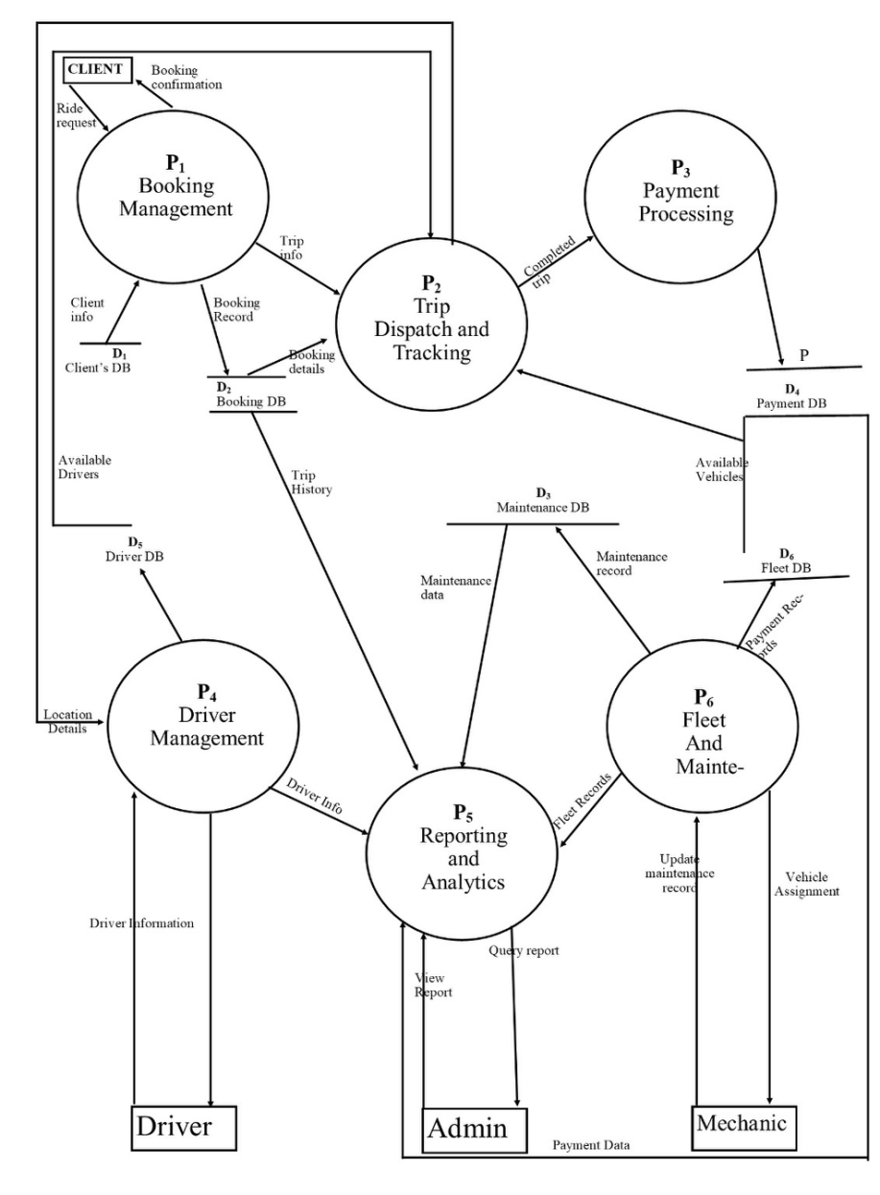Data flow diagram (level 1)

DATA FLOW DIAGRAM (LEVEL 2)
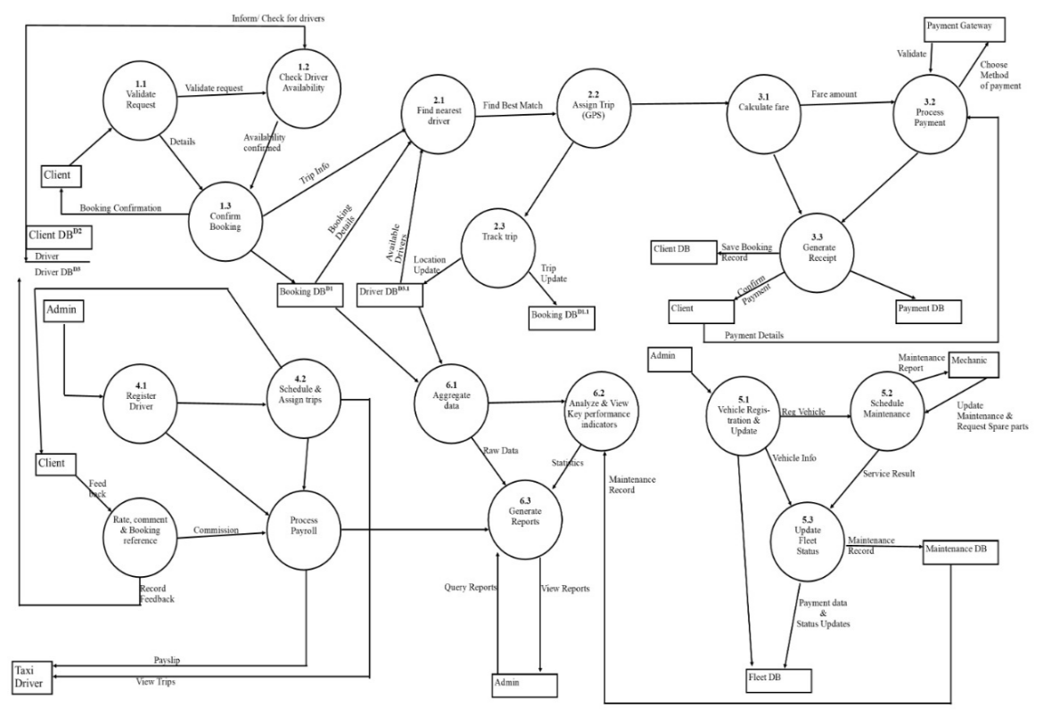
(LEVEL 3) data flow diagram
- Booking management
- Trip tracking and dispatchment
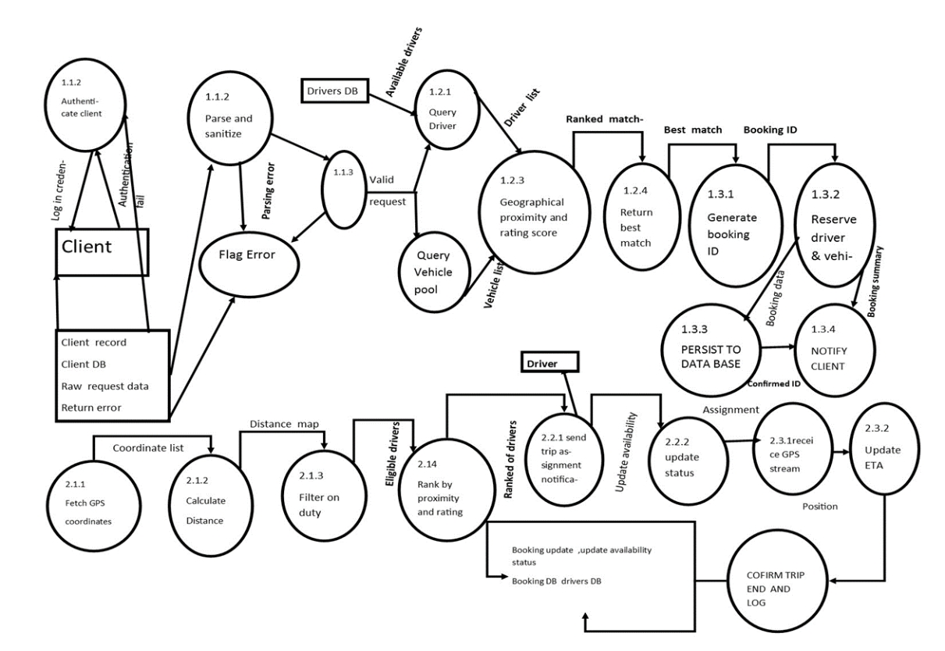
(LEVEL 3) DATA FLOW DIAGRAM
3. Payment processing management
4. Driver management
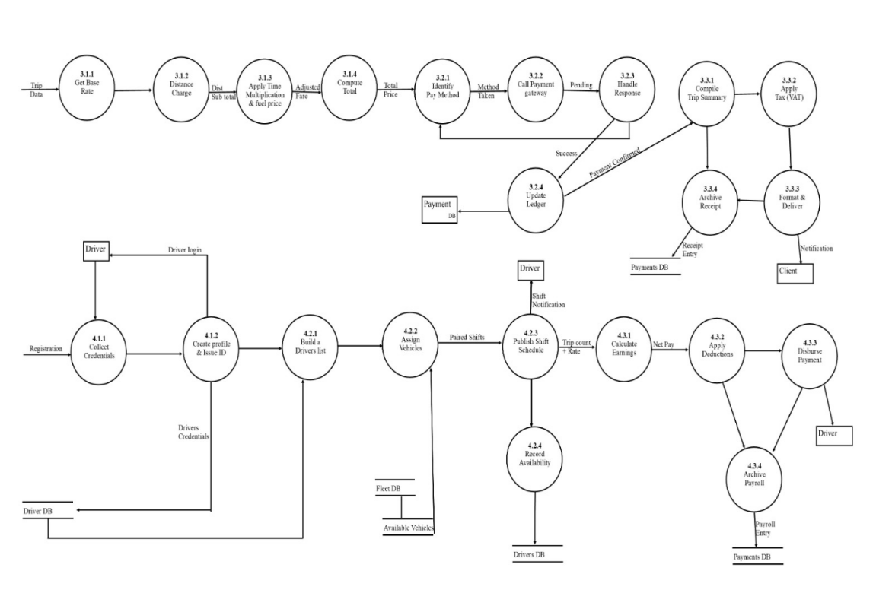
(LEVEL 3) DATAFLOW DIAGRAM
- Fleet and maintenance management
- Reporting and analysis
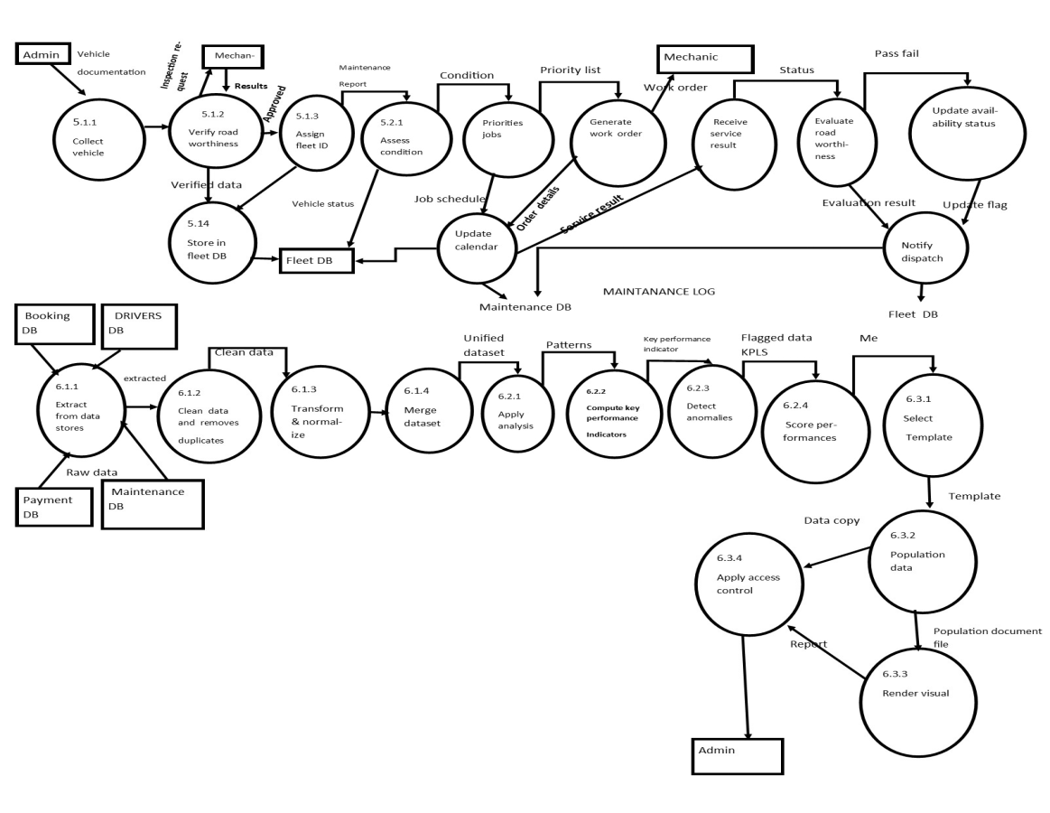

3.FlOWCHARTS
- User registration and login flowchart
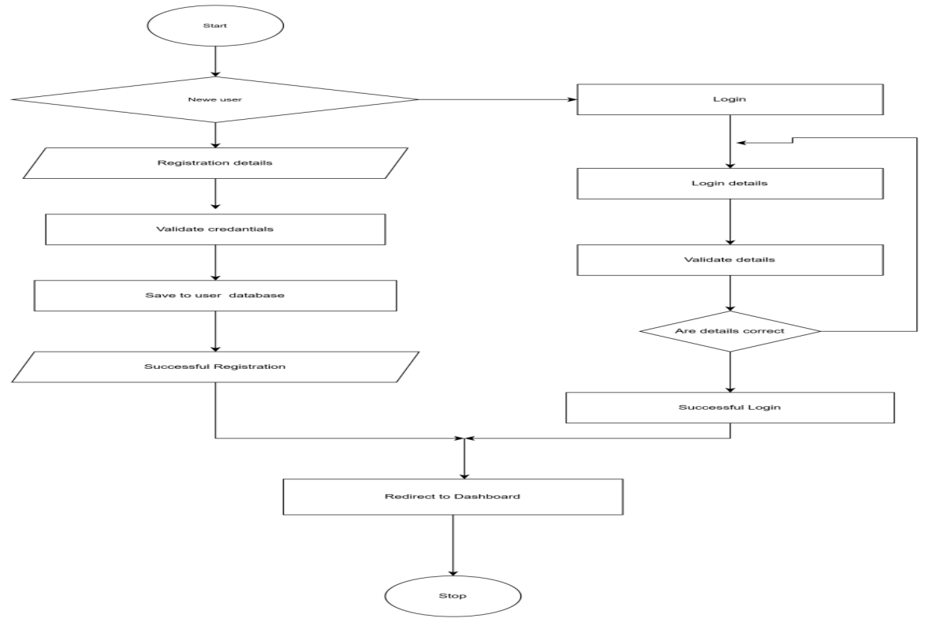

- Ride booking process flowchart

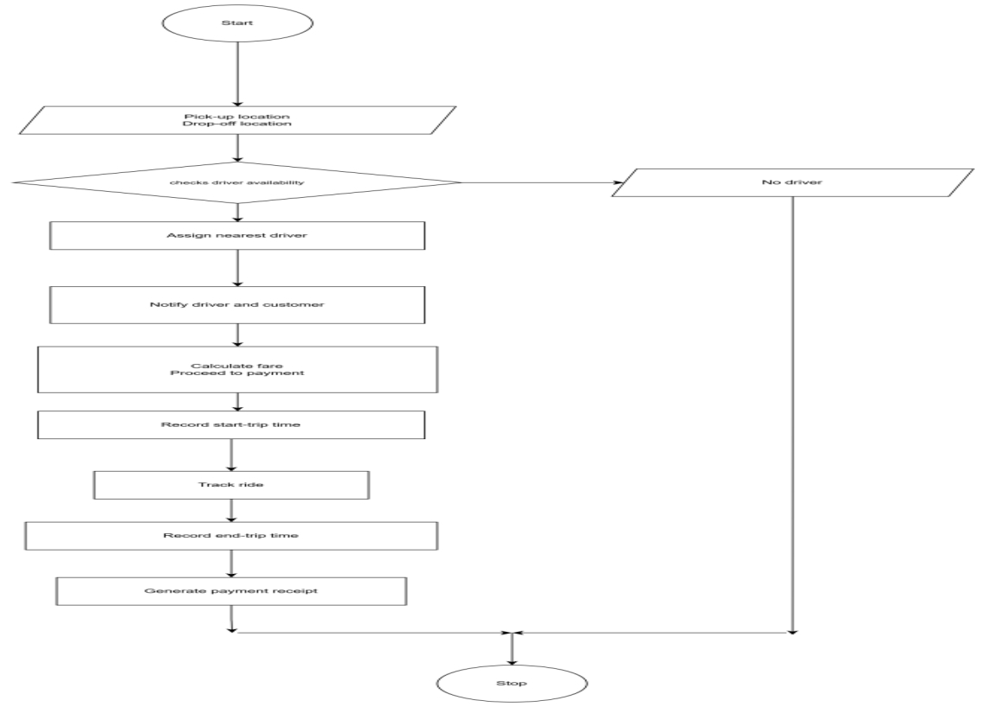

- Payment process flowchart

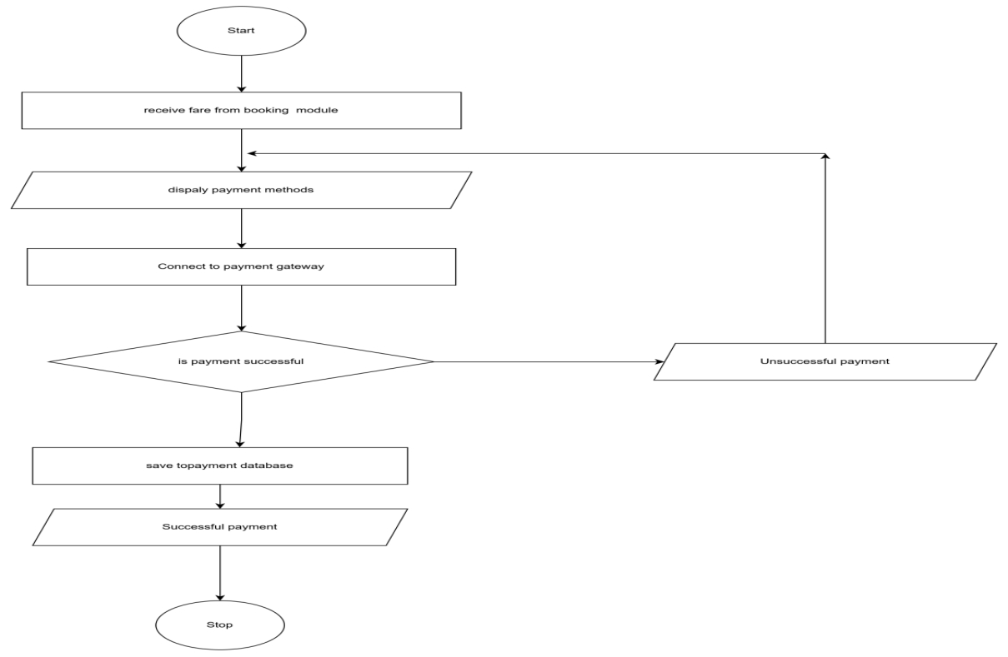

D)Vehicle maintenance flowchart
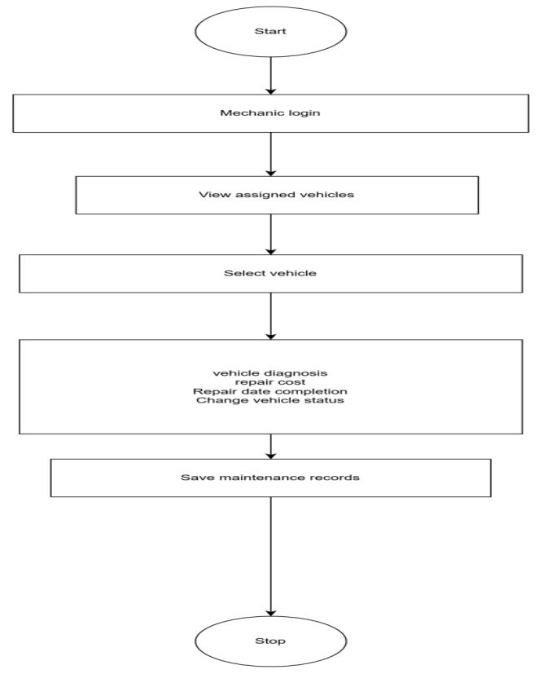

- Driver Ride Assignment flowchart
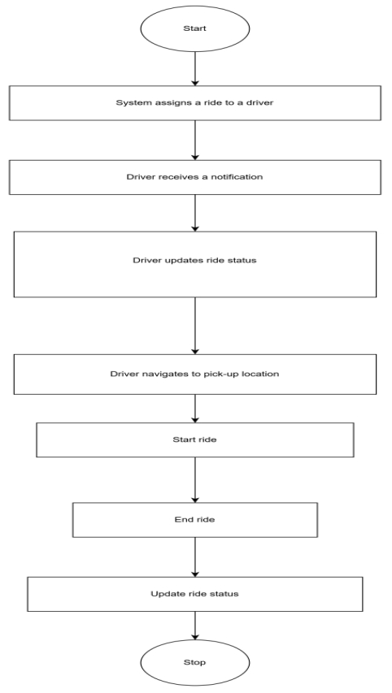

- Report Generation Flowchart
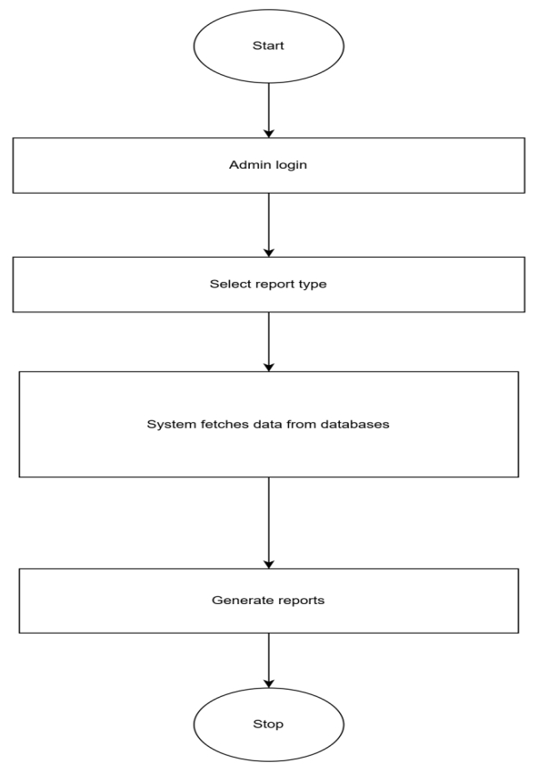

4.ER-DIAGRAMS
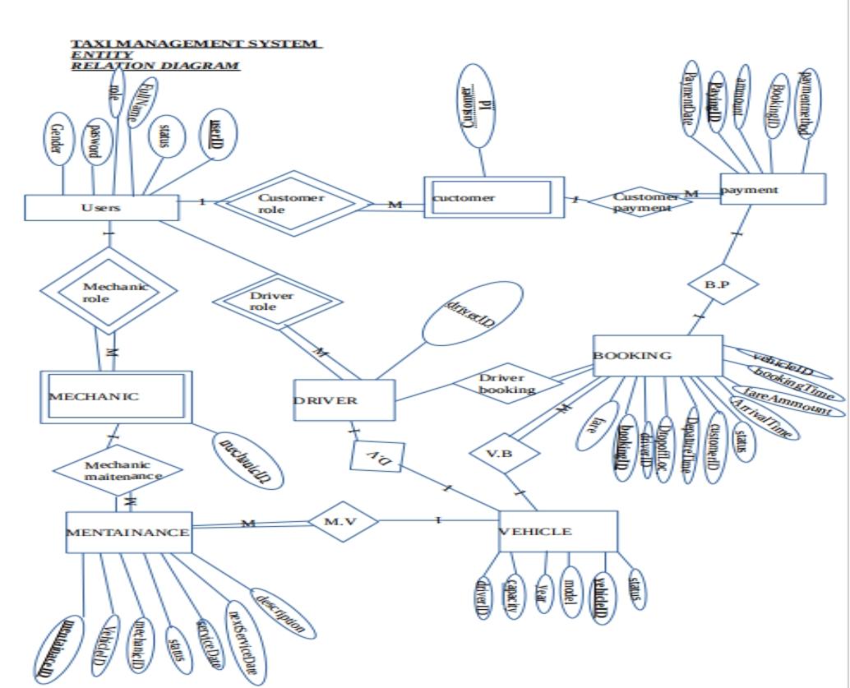

5.UML CLASS DIAGRAMS
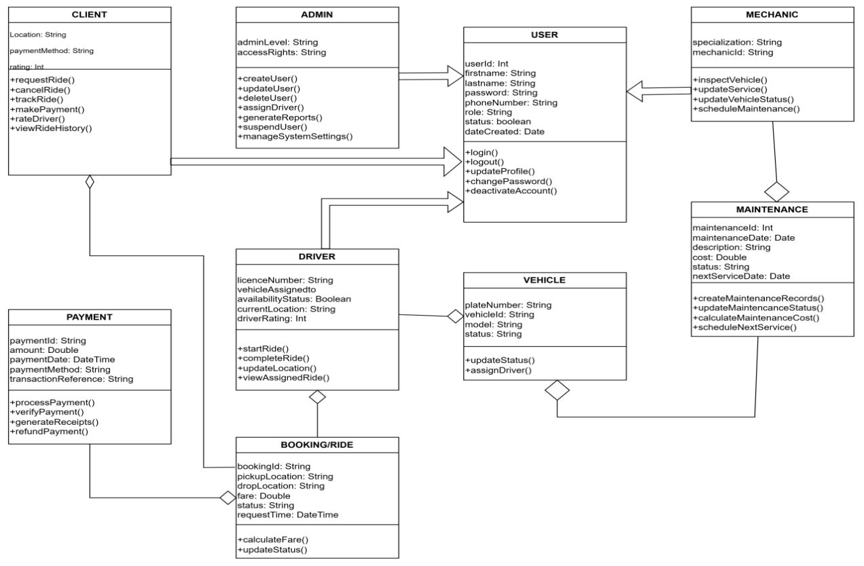

6. DDL
A)Users table(abstract)
CREATE TABLE users (
user_id INT AUTO_INCREMENT PRIMARY KEY,
first_name VARCHAR(50) NOT NULL,
last_name VARCHAR(50) NOT NULL,
email VARCHAR(100) UNIQUE NOT NULL,
phone VARCHAR(20) UNIQUE NOT NULL,
password_hash VARCHAR(255) NOT NULL,
role ENUM('ADMIN','CLIENT','DRIVER','DISPATCHER','MECHANIC') NOT NULL,
created_at TIMESTAMP DEFAULT CURRENT_TIMESTAMP,
status ENUM('ACTIVE','INACTIVE','SUSPENDED') DEFAULT 'ACTIVE'
);

- Drivers table
CREATE TABLE drivers (
driver_id INT PRIMARY KEY,
license_number VARCHAR(50) UNIQUE NOT NULL,
license_expiry DATE NOT NULL,
rating DECIMAL(3,2) DEFAULT 5.00,
availability_status ENUM('AVAILABLE','ON_TRIP','OFFLINE') DEFAULT 'OFFLINE',
FOREIGN KEY (driver_id) REFERENCES users(user_id) ON DELETE CASCADE
);

- Clients table
CREATE TABLE clients (
client_id INT PRIMARY KEY,
preferred_payment_method ENUM('CASH','CARD','MOBILE_MONEY'),
FOREIGN KEY (client_id) REFERENCES users(user_id) ON DELETE CASCADE
);

- Mechanics table
CREATE TABLE mechanics (
mechanic_id INT PRIMARY KEY,
specialization VARCHAR(100),
FOREIGN KEY (mechanic_id) REFERENCES users(user_id) ON DELETE CASCADE
);

- Vehicles table
CREATE TABLE vehicles (
vehicle_id INT AUTO_INCREMENT PRIMARY KEY,
plate_number VARCHAR(20) UNIQUE NOT NULL,
model VARCHAR(50) NOT NULL,
manufacturer VARCHAR(50),
year INT,
color VARCHAR(30),
status ENUM('AVAILABLE','IN_SERVICE','UNDER_MAINTENANCE') DEFAULT 'AVAILABLE',
driver_id INT UNIQUE,
FOREIGN KEY (driver_id) REFERENCES drivers(driver_id)
);

- Rides table
CREATE TABLE rides (
ride_id INT AUTO_INCREMENT PRIMARY KEY,
client_id INT NOT NULL,
driver_id INT,
vehicle_id INT,
pickup_location VARCHAR(255) NOT NULL,
dropoff_location VARCHAR(255) NOT NULL,
request_time TIMESTAMP DEFAULT CURRENT_TIMESTAMP,
start_time TIMESTAMP NULL,
end_time TIMESTAMP NULL,
fare DECIMAL(10,2),
status ENUM('REQUESTED','ASSIGNED','ONGOING','COMPLETED','CANCELLED') DEFAULT 'REQUESTED',
FOREIGN KEY (client_id) REFERENCES clients(client_id),
FOREIGN KEY (driver_id) REFERENCES drivers(driver_id),
FOREIGN KEY (vehicle_id) REFERENCES vehicles(vehicle_id)
);

- Payments table
CREATE TABLE payments (
payment_id INT AUTO_INCREMENT PRIMARY KEY,
ride_id INT NOT NULL,
amount DECIMAL(10,2) NOT NULL,
payment_method ENUM('CASH','CARD','MOBILE_MONEY'),
payment_status ENUM('PENDING','COMPLETED','FAILED') DEFAULT 'PENDING',
transaction_reference VARCHAR(100),
payment_date TIMESTAMP DEFAULT CURRENT_TIMESTAMP,
FOREIGN KEY (ride_id) REFERENCES rides(ride_id) ON DELETE CASCADE
);

- Maintenance table
CREATE TABLE maintenance (
maintenance_id INT AUTO_INCREMENT PRIMARY KEY,
vehicle_id INT NOT NULL,
mechanic_id INT NOT NULL,
description TEXT NOT NULL,
maintenance_date DATE NOT NULL,
cost DECIMAL(10,2),
status ENUM('SCHEDULED','IN_PROGRESS','COMPLETED') DEFAULT 'SCHEDULED',
FOREIGN KEY (vehicle_id) REFERENCES vehicles(vehicle_id),
FOREIGN KEY (mechanic_id) REFERENCES mechanics(mechanic_id)
);

- GPS tracking table
CREATE TABLE gps_tracking (
gps_id INT AUTO_INCREMENT PRIMARY KEY,
vehicle_id INT NOT NULL,
latitude DECIMAL(10,8) NOT NULL,
longitude DECIMAL(11,8) NOT NULL,
recorded_at TIMESTAMP DEFAULT CURRENT_TIMESTAMP,
FOREIGN KEY (vehicle_id) REFERENCES vehicles(vehicle_id) ON DELETE CASCADE
);

- Current location table
CREATE TABLE current_locations (
location_id INT AUTO_INCREMENT PRIMARY KEY,
user_id INT NOT NULL,
latitude DECIMAL(10,8) NOT NULL,
longitude DECIMAL(11,8) NOT NULL,
accuracy_meters DECIMAL(6,2),
last_updated TIMESTAMP DEFAULT CURRENT_TIMESTAMP
ON UPDATE CURRENT_TIMESTAMP,
FOREIGN KEY (user_id) REFERENCES users(user_id)
ON DELETE CASCADE,
UNIQUE (user_id)
);

7.GRAPHICAL USER INTERFACE

Clients view
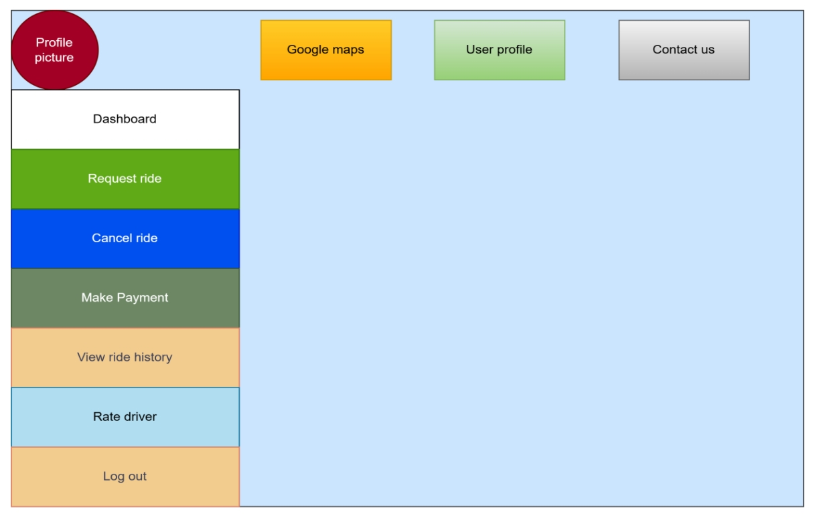

Admin’s view
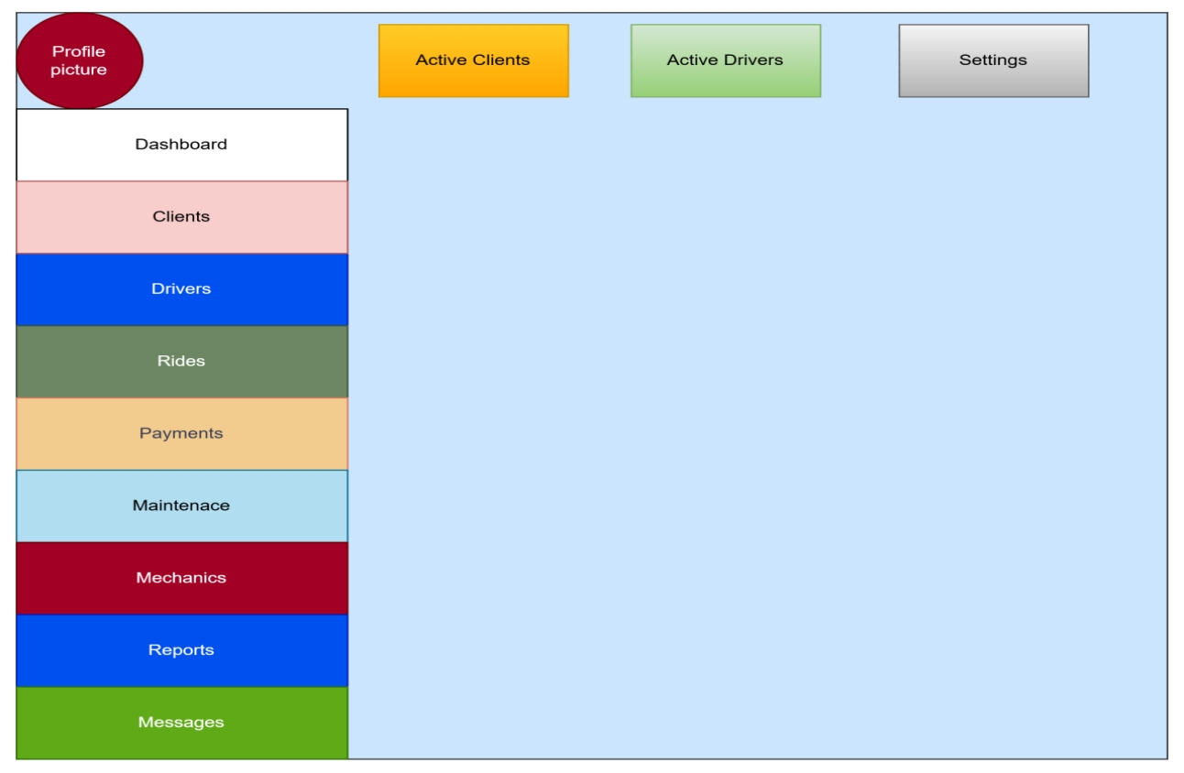

Drivers view
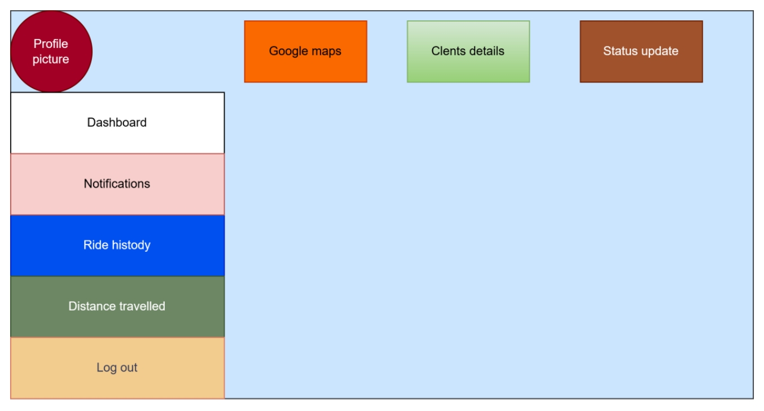

Mechanics view


